**CAFETERIA BILLING AND ORDERING SYSTEM**

**FOR**

**YUMMY CAFE**

**BY**

**Shubha Khadgi**

**Reg No. 7-2-422-116-2019**

**Symbol No. 9918/19**

KIST College of Management

*A Summer Project Report Submitted to*

**Faculty of Management, Tribhuvan University**

in partial fulfillment of the requirements for the degree of

**Bachelor of Information Management**

**Kamalpokhari, Kathmandu**

**Date: ____________**

# **STUDENT DECLARATION**

This is to certify that I have completed the Summer Project entitled ” Cafeteria Ordering & Billing System” under the guidance of “ Mr. Nabin Adhikari” in partial fulfillment of the requirements for the degree of Bachelor of Information Management at Faculty of Management, Tribhuvan University. This is my original work and I have not submitted it earlier elsewhere.

Date: September, 2023

____________________

Signature of the Student

Name: Shubha Khadgi

# **CERTIFICATE FROM THE SUPERVISOR**

This is to certify that the summer project entitled “Food Ordering & Billing System” is an academic work done by “Shubha Khadgi” submitted in the partial fulfillment of the requirements for the degree of Bachelor of Information Management at Faculty of Management, Tribhuvan University under my guidance and supervision. To the best of my knowledge, the information presented by him/her in the summer project report has not been submitted earlier.

______________________

Signature of the Supervisor

Name:

Designation:

Date:

# **ACKNOWLEDGMENTS**

I would like to express my sincere gratitude to Mr. Nabin Adhikari, my supervisor, for his guidance and support throughout my summer project on "Food Ordering & Billing System." His proper guidance and encouragement has helped me in completing this project.

I would also like to thank Tribhuvan University and KIST College of Management for providing me with the opportunity to work on this project and explore my skills and knowledge.

I am grateful to Mr. Surya Bahadur Basnet, our respected coordinator, for his constant supervision and advice, as well as for providing me with the necessary information and support to complete this project.

Furthermore, I would like to express my gratitude to all the individuals who provided me with the information and support I needed to complete this project.

Thank You.

# **EXECUTIVE SUMMARY**

The purpose of "Food Ordering & Billing System" is to simplify the ordering process for customers by offering a user-friendly interface, which allows them to order food hassle-free and to reduce waiting times.

It aims to provide management with access to automated and accurate billing, sales records, and analytical data, so they can make informed decisions, improve efficiency, utilize resources properly, and enhance customer experiences for the user.

Customers can browse the menu, choose their desired food item, view their billing details, and place an order. They can also choose to pay via an online payment gateway or scan a QR code.

Managers are able to add and update new products to the menu. They can prepare the food that is ordered by the customer and call their order number after the food is prepared. Managers can also view monthly reports on their dashboard along with a bird’s eye view of pending orders.

The integration of this food and billing system will have a significant impact on the overall efficiency and effectiveness of the business's operations. The integration of an online payment gateway and QR code system will offer customers convenient and secure payment options, enhancing the overall user experience and speeding up transaction processing.

**TABLE OF CONTENTS**

**STUDENT DECLARATION** i

**CERTIFICATE FROM THE SUPERVISOR** ii

**ACKNOWLEDGMENTS** iii

**EXECUTIVE SUMMARY** iv

**LIST OF FIGUERS** vii

**LIST OF TABLES** viii

**ABBREVIATIONS** ix

**CHAPTER ONE: INTRODUCTION** 1

1.1 Background 1

1.2 Introduction of the organization 1

1.3 Current Situation of the organization 1

1.4 Problem Statements 2

1.5 Objective of Project 3

General Objectives 3

Specific Objective 3

1.6 Methodology Used 3

1.6.1 Project Framework 4

1.6.2 Data and Information Collection 5

1.6.3 Tools Used 6

**CHAPTER TWO: ANALYSIS OF TASKS AND ACTIVITIES** 7

2.1 Analysis of tasks and activities 7

i. Identification of the Cafeteria 7

ii. Gathering Information about the Cafeteria 7

iii. Analyzing Existing Processes 7

iv. Identifying Problem Areas 7

v. Proposing Solutions 7

vi. System Design and Development 7

vii. Testing and Validation 7

2.2 Analysis of Problem 8

2.3 Feasibility Study 8

2.3.1 Operational Feasibility 8

2.3.2 Technical Feasibility 8

2.3.3 Economic Feasibility 8

2.4 Requirement Analysis 8

2.4.1 Functional Requirements 8

2.4.2 Non-Functional Requirements 9

2.5 System Modeling 10

2.5.1 Use Case Diagram 10

2.5.2 Class Diagram 11

2.5.3 Sequence Diagram 12

2.6 System Design 13

2.6.1 Implementation Details of Modules 13

2.7 System Testing 14

2.7.1 Unit Testing 14

2.7.2 Validation Testing 16

2.7.3 Test Cases 16

**CHAPTER THREE: DISCUSSION AND CONCLUSION** 24

3.1 Discussion 24

3.2 Conclusion 24

3.3 Recommendation 24

**REFERENCES** 25

**APPENDICES I** 26

**APPENDICES II** 30

# **LIST OF FIGUERS**

Figure 1: Project Framework 4

Figure 2.1: Use Case Diagram 10

Figure 2.2: Class Diagram 11

Figure 2.3: Sequence Diagram 12

Figure 2.4: User Module 13

Figure 2.5: Manager Module 14

Figure 2.6: Email Validation_UT-01 18

Figure 2.7: Email Validation_UT-02 18

Figure 2.8: Password Length Validation_UT-03 19

Figure 2.9: Password Validation_UT-04 19

Figure 2.10: Bill Calculation_UT-06 20

Figure 2.11: User Login Validation_VT-03 20

Figure 2.12: Order Number Validation_VT-04 21

Figure 2.13: Confirm Order Validation_VT-05 21

Figure 2.14: Add New Product_TC-01(i) 22

Figure 2.15: Add New Product_TC-01(ii) 22

Figure 2.16: Update Product_TC-02 22

Figure 2.17: Delete Product_TC-03 23

# **LIST OF TABLES**

Table 2.1: Unit Testing 15

Table 2.2: Validation Testing 16

Table 2.3: Test Cases 17

# **ABBREVIATIONS**

|  |  |
| --- | --- |
| BIM | Bachelor in Information Management |
| CSS | Cascading Style Sheet |
| HTML | Hyper Text Markup Language |
| JS | JavaScript |
| PHP | Hypertext Preprocessor |
| TU | Tribhuvan University |

# **CHAPTER ONE: INTRODUCTION**

## **1.1 Background**

The writing of a Summer Project report is an essential requirement for graduation from the Faculty of Management, Tribhuvan University. This assignment is an off-the classroom and field-based study project which allows students to reflect and integrate their learning over their five semesters of study. The project is of three credit hours.

This report is based on the organization, Yummy Cafe, which is a college cafeteria providing its services at KIST College. Traditionally, ordering food at any restaurant or cafes involve a manual process, which is both time-consuming and prone to errors. Customers have to wait in long queues, and do not have easy access to payment methods they prefer. Additionally, managing the financial aspects of a business can be a challenge, with paper-based billing systems requiring high levels of manual input and quick computations.

Recognizing this need to optimize business operations and offer a better customer experience, the idea of "Cafeteria Ordering & Billing System" was developed.

## **1.2 Introduction of the organization**

Yummy Cafe is a well-established catering company that has been providing cafeteria services to multiple institutions and organizations, including KIST College of Management.

It has been in operation for many years and has successfully established its presence in the industry. It has gained recognition for its expertise in providing quality catering services to a diverse range of academic institutions, also including Padmakanya Multiple Campus located at Dillibazar and Prime CA College situated in Lagankhel.

## **1.3 Current Situation of the organization**

Currently, Yummy Café’s cafeteria service operates using an all manual system that involves cash transactions and calculations being done manually in all of its operating colleges. This process is time-consuming and prone to errors, leading to long waiting queues, billing inaccuracies, and customer dissatisfaction.

It currently relies on Excel sheets to calculate its total sales and revenue. While Excel can be a useful tool for data analysis, it has its limitations, especially when it comes to managing complex billing processes and large amounts of data.

For instance, the manual entry of data into Excel sheets can lead to errors and inconsistencies, which can undermine the accuracy and reliability of the data. Additionally, manual data entry can be time-consuming and can take valuable resources away from other essential tasks.

## **1.4 Problem Statements**

Yummy Cafe is facing several challenges in its day-to-day operations due to the absence of an automated system. These challenges have a negative impact on the organization's reputation, customer satisfaction levels, and revenue generation. Therefore, there is an urgent need to implement a more streamlined and efficient system that can address these issues and ensure the smooth functioning of the organization.

It is currently facing the following problems that are hindering its growth and success.

1. **Difficulty in maintaining record of cafeteria :**

Yummy Café is currently operating in multiple colleges, and managing the financial records of all the various cafeterias manually has become a challenging task. Relying on an Excel sheet to update the financial status of the company for each cafeteria is time-consuming and prone to errors. This makes it difficult to keep track of the financial status of each cafeteria and the company as a whole, and can lead to inaccurate financial reporting and budgeting.

1. **Manual billing and payment processes :**

The manual calculation process is time-consuming and prone to errors. Since the billing and payment processes are done manually, it requires a significant amount of time and effort to generate bills, invoices, and receipts, and to process payments. This can cause delays in the billing and payment process, which can ultimately affect the cash flow of the business.

1. **Manual inventory management :**

With a manual system, inventory levels are tracked using pen and paper or spreadsheets, which can lead to inaccuracies in inventory levels. This can result in overstocking or understocking of certain items, which can ultimately lead to financial losses for the business.

1. **Inefficient cost management :**

The organization does not have a structured system for managing costs, causing overspending and negatively impacting the financial health of the business. There is no budgeting or forecasting system in place, which has made it difficult for the management team to plan and make informed decisions for the future of the business.

1. **Inadequate forecasting and budgeting :**

The manual nature of the company's financial reporting process, which is prone to errors and delays has worsened the problem for Yummy Café. The lack of accurate financial information also hinders the management team's ability to make informed decisions, leading to a higher risk of financial losses and missed opportunities.

## **1.5 Objective of Project**

An objective is a clear and specific goal or target that one wants to achieve. Objectives are used to guide actions and plans, making them more focused and measurable.

### **General Objectives**

A general objective is a statement that communicates the overall goal of a research or project.

* To reduce paperwork
* To reduce operational time
* Increase accuracy and reliability
* Maintain customer satisfaction

### **Specific Objective**

A specific objective is detailed objectives that describe what will be researched during the study.

* To develop an easy and simple user interactive website that is easily accessible  and user friendly
* To computerized records keeping of the customers
* To let customers view menu and order food online
* To make monetary transaction process easier
* To reduce long waiting queues

## **1.6 Methodology Used**

Methodology in research refers to the systematic and structured approach used to conduct a study, investigation, or project. It encompasses the strategies, techniques, and principles that guide researchers in collecting and analyzing data, drawing conclusions, and achieving their research objectives. Methodology serves as a roadmap for researchers, providing a clear framework for how they will address their research questions or problems.

It involves making informed choices about research design, data collection methods, data analysis techniques, and the overall process of inquiry. Methodology is the foundation that ensures research is conducted in an organized, rigorous, and reliable manner, allowing for the generation of credible and valuable insights or findings.

### **1.6.1 Project Framework**

A project framework is a structured and standardized set of project management practices, templates, and tools that serve as a guide for the initiation, planning, execution, monitoring, control, and closure of a project. Its primary purpose is to facilitate systematic planning and implementation to ensure that the project is completed within the defined time frame and meets its objectives.

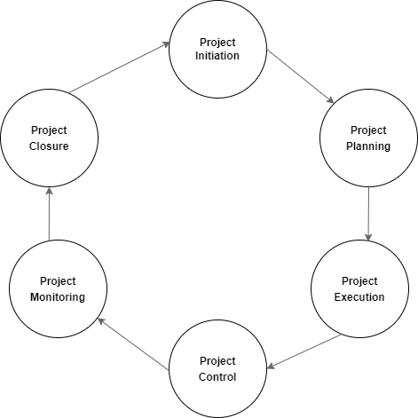

Figure 1: Project Framework

#### **Project Initiation**

In this phase, the project's goals and objectives are defined. It involves assessing the project's feasibility and gathering initial information.

#### **Project Planning**

During this phase, a detailed project plan is created. It includes setting timelines, allocating resources, and selecting the necessary tools and technologies.

#### **Project Execution**

The project's actual work is carried out in this phase. Tasks are implemented, and collaboration among team members takes place.

#### **Project Control**

This phase involves constant monitoring of the project's progress and performance. Adjustments are made as needed to keep the project on track.

#### **Project Monitoring**

Regular checks are conducted in this phase to ensure that the project is progressing as planned. The focus is on meeting the project's defined goals and objectives.

#### **Project Closure**

The final phase involves documenting the project's results and outcomes. Approvals are obtained, and deliverables are handed over as necessary to conclude the project.

### **1.6.2 Data and Information Collection**

* **Observation**

Through direct observation of cafeteria operations, we tracked how customers placed orders, how staff prepared and served food, and how transactions were conducted. This allowed us to identify ongoing operations and areas for improvement.

* **Interviews**

Through structured interviews, we gained detailed insights into the cafeteria's daily operations, menu management, payment methods, and staff-customer interactions. These insights informed system design and feature prioritization.

#### **Research**

Research served as a means to validate and cross-reference the information obtained through interviews and observation, ensuring the robustness and accuracy of our data.

### **1.6.3 Tools Used**

* **Laravel**

Laravel was chosen as the web application framework for its robust features and ease of development, streamlining the creation of the cafeteria ordering and billing system.

* **phpMyAdmin**

phpMyAdmin served as the database management tool, providing a user-friendly interface for database administration and data handling.

* **Visual Studio Code**

Visual Studio Code offered a versatile and efficient code editor for writing and debugging the systems codebase, enhancing development productivity.

* **XAMPP Server**

XAMPP provided a local server environment for testing and development, ensuring that the system functions correctly before deployment.

* **JavaScript**

JavaScript was used to add interactivity and dynamic features to the system's web interface, improving the user experience.

* **CSS**

Cascading Style Sheets (CSS) helped design and style the system's frontend, ensuring an appealing and consistent visual presentation for users.

# **CHAPTER TWO: ANALYSIS OF TASKS AND ACTIVITIES**

## **2.1 Analysis of tasks and activities**

Numerous tasks and activities were undertaken to achieve the objective of this project, which is to create an efficient and user-friendly cafeteria billing and ordering system. The tasks and activities that have been completed are outlined as follows:

### **Identification of the Cafeteria**

Selecting the cafeteria for this project was the initial step. After conducting thorough research and evaluations, “Yummy Café” was chosen for this project.

### **Gathering Information about the Cafeteria**

Once the cafeteria was selected, the next task was to collect comprehensive information about Yummy Cafe. To obtain this information, I designed a structured questionnaire and conducted interviews with the cafeteria management and staff to understand their operations, menu, and pricing.

### **Analyzing Existing Processes**

With the information in hand, any inefficiencies in the management and operation of Yummy Café was closely monitored, and studied for improvement.

### **Identifying Problem Areas**

Through the analysis of the existing processes, problem areas were identified. These issues ranged from long wait times during peak hours to inaccurate billing and order processing.

### **Proposing Solutions**

Once the problems were identified, solutions were developed. The solution was the introduction and implementation of a user-friendly ordering platform, with billing procedures, and integrated payment gateways to enhance customer convenience.

### **System Design and Development**

Following the proposal of solutions, design and development phase was initiated. This involved creating a user-friendly interface for customers to place orders digitally, designing an efficient billing system, and integrating payment processing capabilities.

### **Testing and Validation**

Tests and validation were conducted to ensure the newly developed cafeteria billing and ordering system functioned seamlessly.

## **2.2 Analysis of Problem**

The analysis of the problem involves a detailed examination and study of the challenges faced by Yummy Cafe due to its reliance on manual processes for various aspects of its operations. These challenges include difficulties in financial record-keeping, billing, inventory management, cost control, and forecasting.

## **2.3 Feasibility Study**

A feasibility study is like a detailed investigation to figure out if a project or idea is a good and practical one before actually doing it. It helps decide if it's worth the time and money.

This study is divided into three key sections:

### **2.3.1 Operational Feasibility**

Operational feasibility is conducted to check if the new system will work well in the cafe's daily operations. The system should be easy to use, and should help the staff do their jobs better.

### **2.3.2 Technical Feasibility**

Technical feasibility study checks for accessibility of technical resources in the organization. This looks at whether it's easy to get the things needed for the system, like equipment and software in the internet without much difficulty.

### **2.3.3 Economic Feasibility**

Economic feasibility involves evaluating the potential costs and benefits associated with the project to determine if it makes economic sense to proceed.

## **2.4 Requirement Analysis**

Requirement analysis is the process of gathering information about new or existing systems from the user. It studies what the system should do or how the system should act when user search for something. The requirements can be classified as:

### **2.4.1 Functional Requirements**

Functional requirements describe what a system should do. The functional requirement of the cafeteria system are:

**User Module**

* Users can log in using their credentials
* Users should be able to view the menu
* Items should be categorized (e.g., breakfast, lunch, snacks)
* Users can select items from the menu to add to their order
* Users can choose payment methods
* Users can track the status of their order

**Manager Module**

* Managers can add, edit, or delete items from the menu
* Ability to set item prices, and their descriptions
* Managers can view and manage incoming orders
* Ability to set status of order (e.g., pending, paid, completed)
* Generate monthly sales reports

### **2.4.2 Non-Functional Requirements**

Non-functional requirements describe how a system should do it. The non-functional requirement of the cafeteria system are:

* Maintainability
* Availability
* Reliability
* Usability

## **2.5 System Modeling**

System modeling is a way of creating a simplified representation or model of a real-world system to understand, design, or analyze it more effectively.

### **2.5.1 Use Case Diagram**

A use case diagram is like a high-level map of how a system interacts with its users. It shows the different actions (use cases) that users can perform and how they relate to the system.

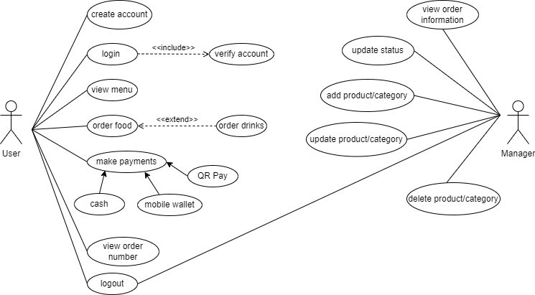

Figure 2.1: Use Case Diagram

### **2.5.2 Class Diagram**

A class diagram is a blueprint that lays out the structure of a system. Class diagrams help in designing and organizing the structure of a system, making it easier to create software code.

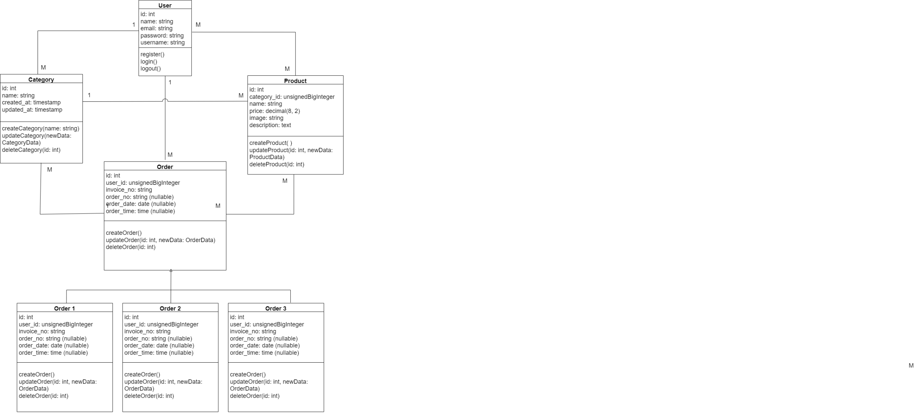

Figure 2.2: Class Diagram

### **2.5.3 Sequence Diagram**

A sequence diagram is a step-by-step flowchart that shows how objects or components interact over time to achieve a specific task or scenario. They are useful for understanding and visualizing the interactions and timing between different parts of a system, especially during the execution of specific functions or processes.

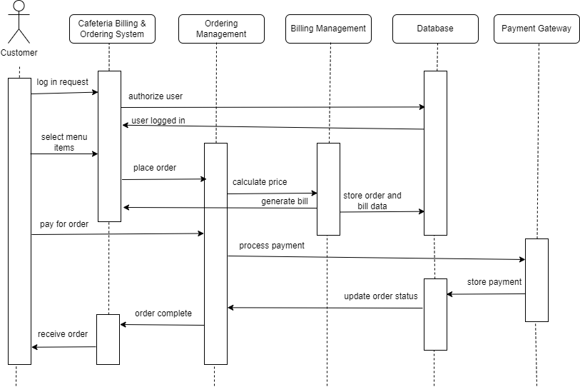

Figure 2.3: Sequence Diagram

## **2.6 System Design**

System design is the process of creating a detailed plan or blueprint for how a system will be built and function. It is a crucial phase in the development process of any system.

### **2.6.1 Implementation Details of Modules**

**User Module**

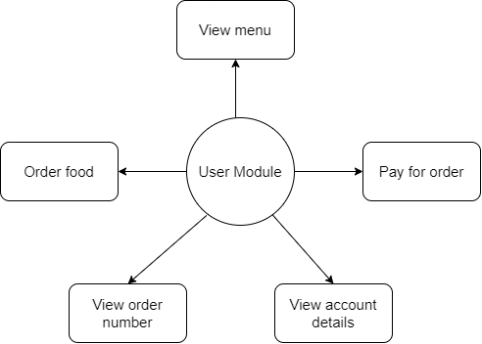

Figure 2.4: User Module

**Manager Module**

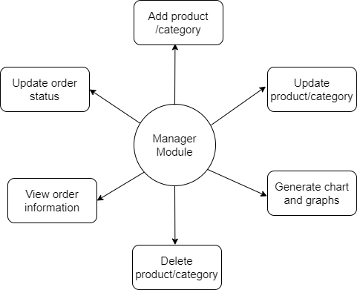

Figure 2.5: Manager Module

## **2.7 System Testing**

System testing is an important phase in the development process, where a developed system is thoroughly examined and evaluated to ensure that it meets its intended requirements and functions correctly.

### **2.7.1 Unit Testing**

Unit testing focuses on testing the smallest building blocks of a software application, which are usually individual functions or methods. Test cases are created to verify the behavior of the unit. These test cases include various scenarios that the unit is expected to handle correctly.

|  |  |  |  |  |  |
| --- | --- | --- | --- | --- | --- |
| **Test Case** | **Description** | **Input** | **Expected Output** | **Actual Output** | **Status** |
| UT-01 | Email validation | Enter an email without "@" | Display error message | Error message displayed | Pass |
| UT-02 | Email validation | Enter an email ending with “@” | Display error message | Error message displayed | Pass |
| UT-03 | Password length validation | Enter password less than 8 character | Display error message | Error message displayed | Pass |
| UT-04 | Password validation | Enter different password in confirmation field | Display error message | Error message displayed | Pass |
| UT-05 | Bill calculation | Calculate the total amount in the bill | Correct total amount displayed | Correct total amount displayed | Pass |

Table 2.1: Unit Testing

### **2.7.2 Validation Testing**

Validation testing is the process of evaluating software during or at the end of the development process to determine whether it satisfies specified requirements.

|  |  |  |  |  |  |
| --- | --- | --- | --- | --- | --- |
| **Test Case** | **Description** | **Input** | **Expected Output** | **Actual Output** | **Status** |
| VT-01 | User login validation | Log in with valid credentials | User is logged in successfully | User logged in successfully | Pass |
| VT-02 | User login validation | Log in with invalid credentials | Does not log in | Not logged in | Pass |
| VT-03 | User login validation | Login with empty field | Display error message | Error message displayed | Pass |
| VT-04 | Order number validation | Generate order numbers | Each order has a unique order number | Each order has a unique order number | Pass |
| VT-05 | Confirm order validation | Confirm order for an empty order | Display error alert | Error alert displayed | Pass |

Table 2.2: Validation Testing

### **2.7.3 Test Cases**

Creating test cases for a system involves specifying scenarios and conditions that need to be tested to ensure the system functions correctly.

|  |  |  |  |  |  |
| --- | --- | --- | --- | --- | --- |
| **Test Case** | **Description** | **Input** | **Expected Output** | **Actual Output** | **Status** |
| TC-01 | Add new product | Add a new product to the menu | Product is added successfully | Product added successfully | Pass |
| TC-02 | Update product | Update the details of an existing product | Product details are updated | Product details updated | Pass |
| TC-03 | Delete product | Delete an existing product from the menu | Product is deleted successfully | Product deleted successfully | Pass |
| TC-04 | Add product to a new category | Assign a product to a new category | Product is added to the new category | Product added to the new category | Pass |
| TC-05 | Bill date/time generation | Generate the date and time on the bill | Correct date and time format displayed | Correct date and time format displayed | Pass |

Table 2.3: Test Cases

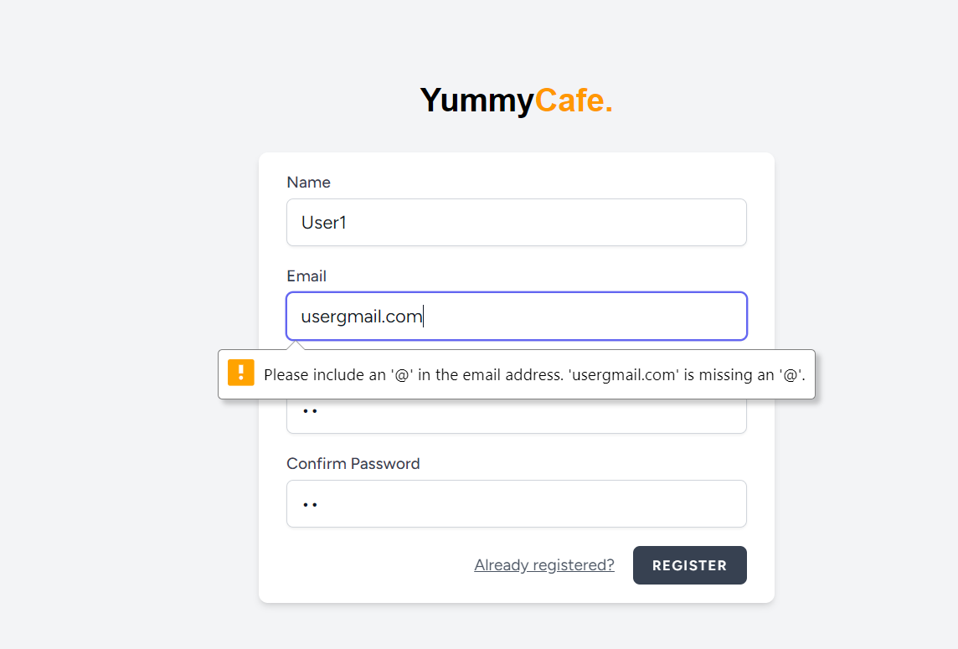

Figure 2.6: Email Validation_UT-01

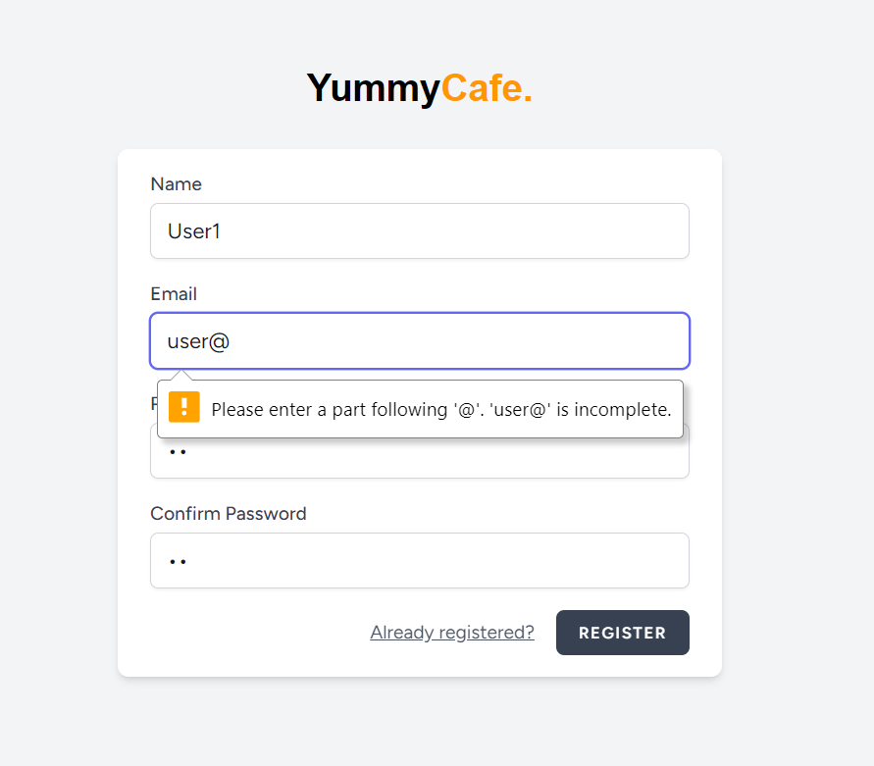

Figure 2.7: Email Validation_UT-02

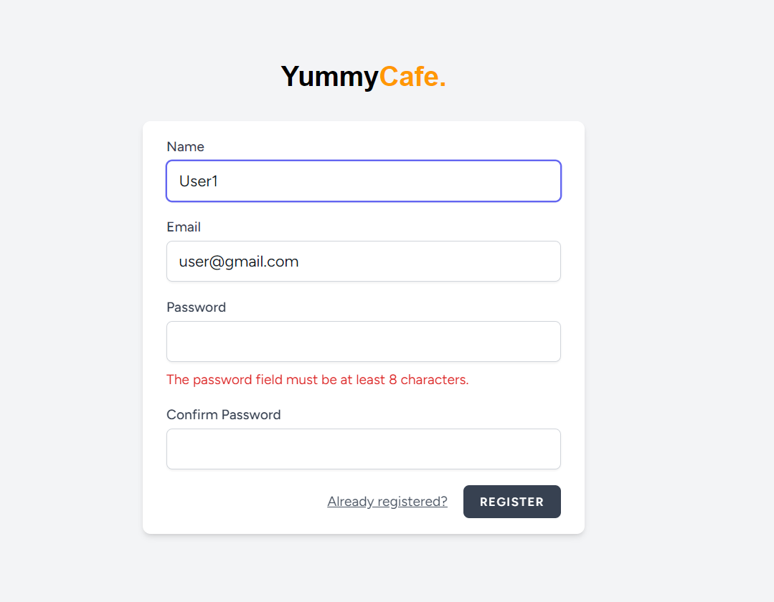

Figure 2.8: Password Length Validation_UT-03

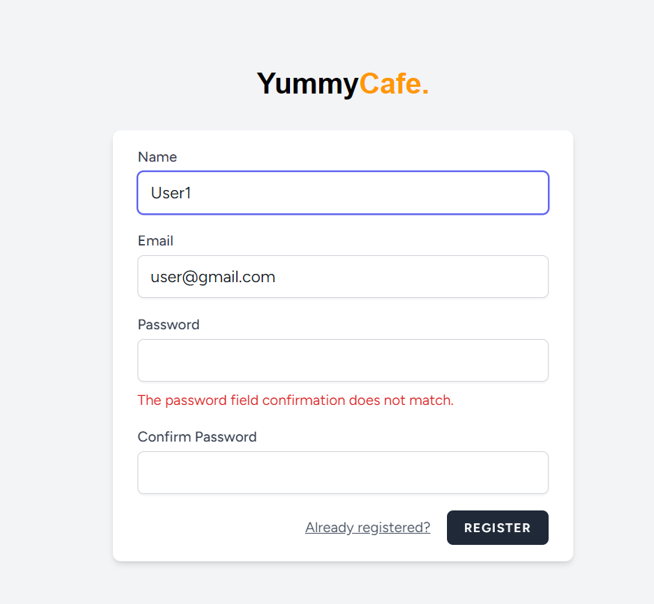

Figure 2.9: Password Validation_UT-04

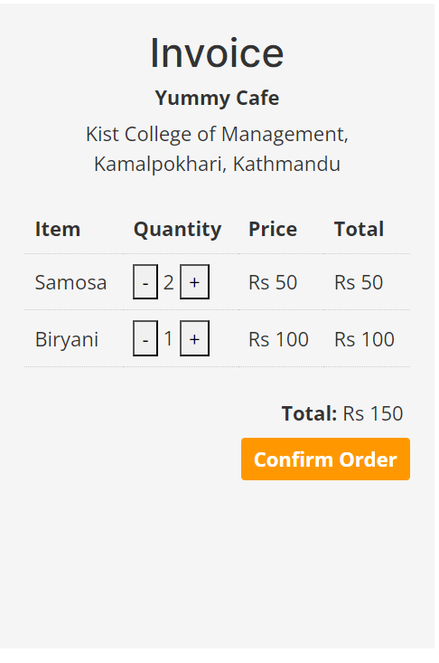

Figure 2.10: Bill Calculation_UT-06

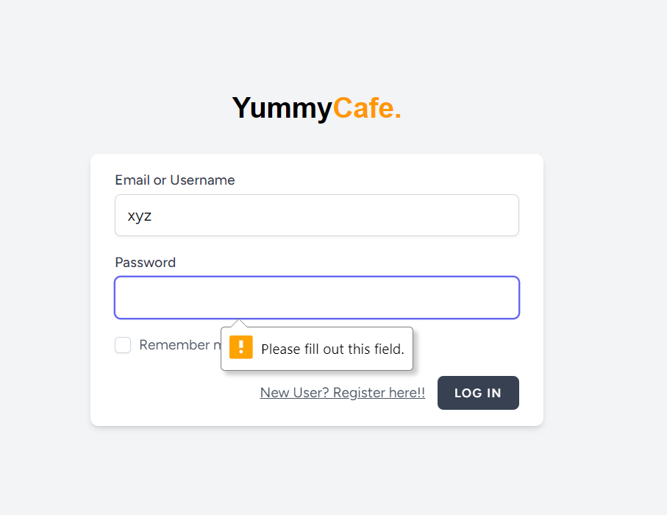

Figure 2.11: User Login Validation_VT-03

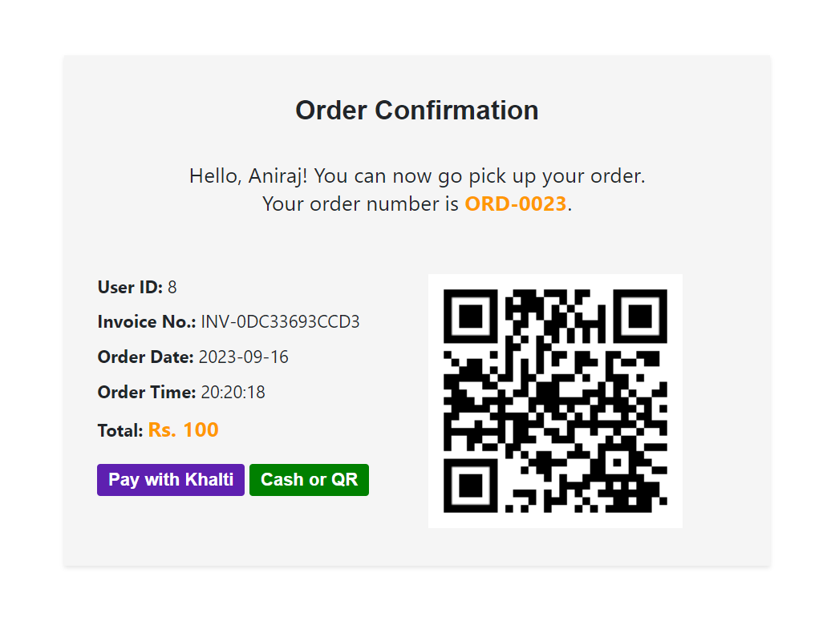

Figure 2.12: Order Number Validation_VT-04

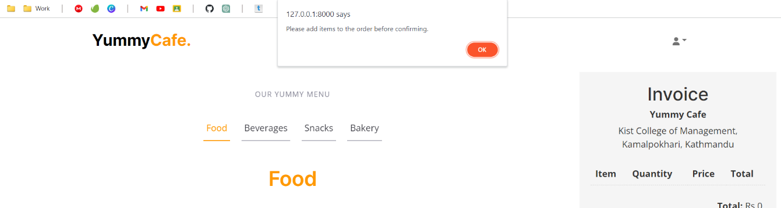

Figure 2.13: Confirm Order Validation_VT-05

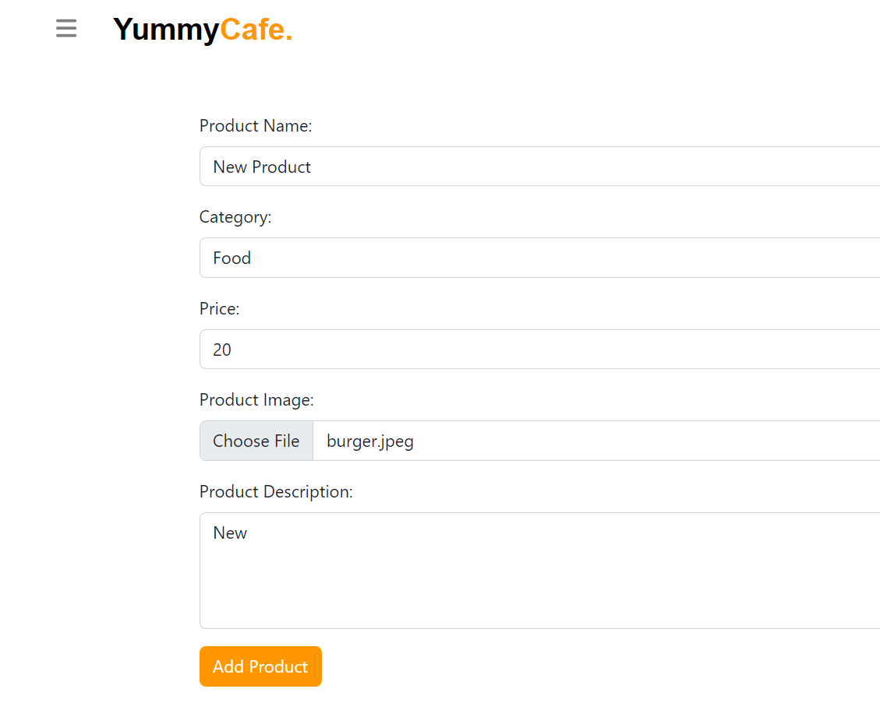

Figure 2.14: Add New Product_TC-01(i)

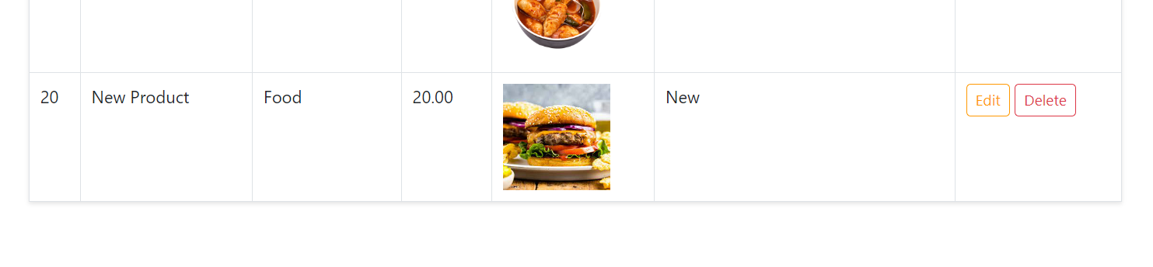

Figure 2.15: Add New Product_TC-01(ii)

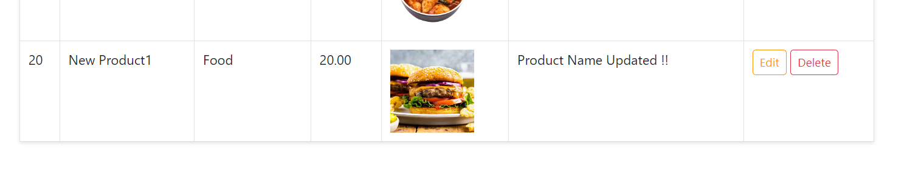

Figure 2.16: Update Product_TC-02

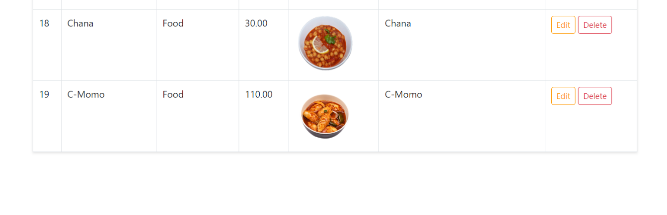

Figure 2.17: Delete Product_TC-03

# **CHAPTER THREE: DISCUSSION AND CONCLUSION**

## **3.1 Discussion**

During this project, I worked to make Yummy Cafe operate better by taking on the task to develop a user-friendly system for the cafeteria.

The main aim of “Cafeteria Billing & Ordering System” is to provide the management with access to automated and accurate billing, sales records, and analytical data, so they can make informed decisions, improve efficiency, utilize resources properly, and enhance customer experiences for the user.

I collaborated and communicated with the manager of the cafeteria to understand the requirements of the company. We also looked at whether it would make sense for Yummy Cafe to use this new system. We found out that it would help the cafe make more money and work better. This is good because it means the cafe will be in good shape financially, and everything will run more smoothly. Then, we decided on what the system should do and how it should do it through the system modeling processes.

## **3.2 Conclusion**

To conclude, the “Cafeteria Billing & Ordering System” has been a success, but is still a work-in-progress. The system addresses specific problems faced by the company, like long waiting queues, inaccurate billing, and more.

It is designed to provide the user with a easy, user-friendly site, integrated with online payment gateway for hassle free payments and for the management to better operate their business, increase their efficiency, and record their sales reports/ analytics.

## **3.3 Recommendation**

Looking forward, a feature can be added to help keep track of the stocks and inventory, so that no items or ingredients are unavailable when needed. It will also minimize cost and help to reduce waste.

An employee management system can also be integrated to make it easier to handle things like work schedules and track progress of the employees. These changes could help run the business even better.

# **REFERENCES**

*Laravel Documentation*. (n.d). Retrieved from Laravel: https://laravel.com/doc/

Larman, C. (2004). *Applying UML and Patterns, 3rd Edition.* Uttar Pradesh: Pearson.

*MySQL Documentation*. (n.d). Retrieved from MySQL: https://dev.mysql.com/doc/

Sommerville. (2018). *Software Engineering, 10th Edition.* Uttar Pradesh: Pearson India.

*Web Development Tutorials*. (n.d). Retrieved from Tutorials Point: https://www.tutorialspoint.com/web_development_tutorials.htm

# **APPENDICES I**

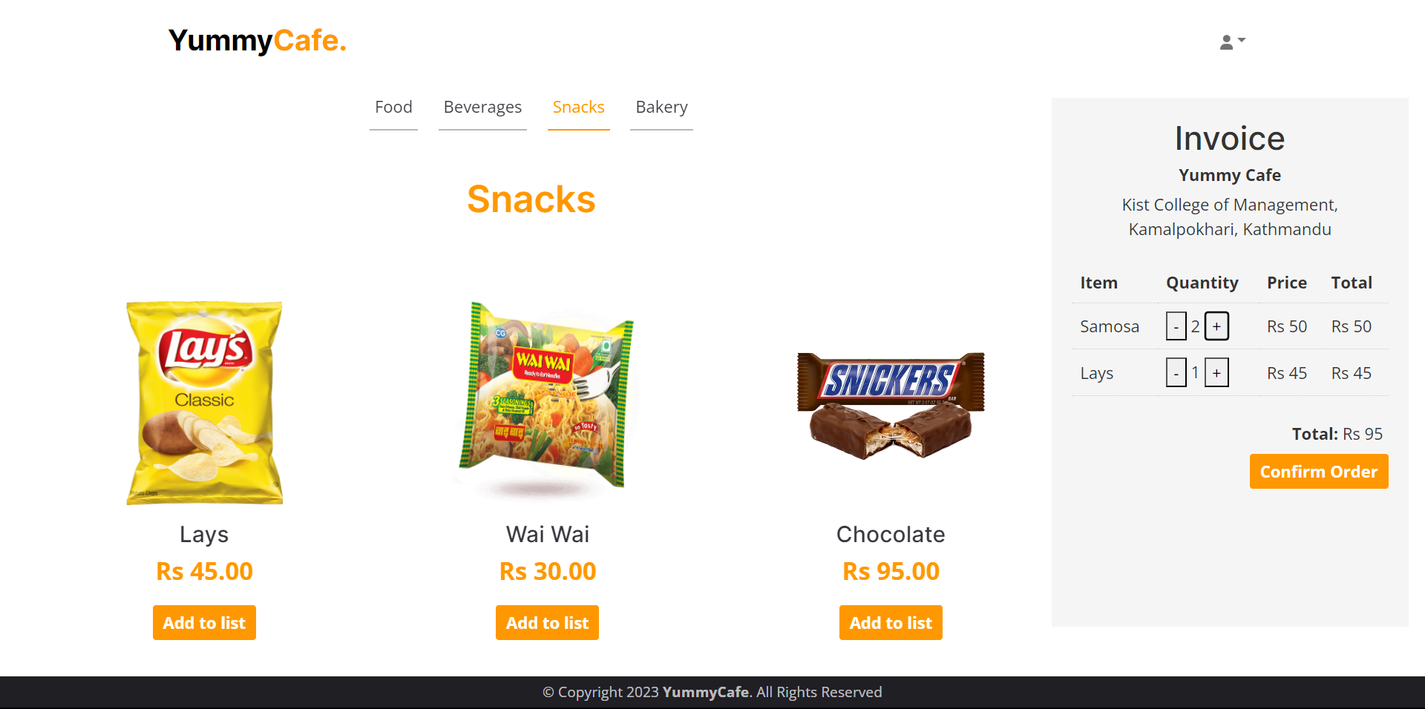

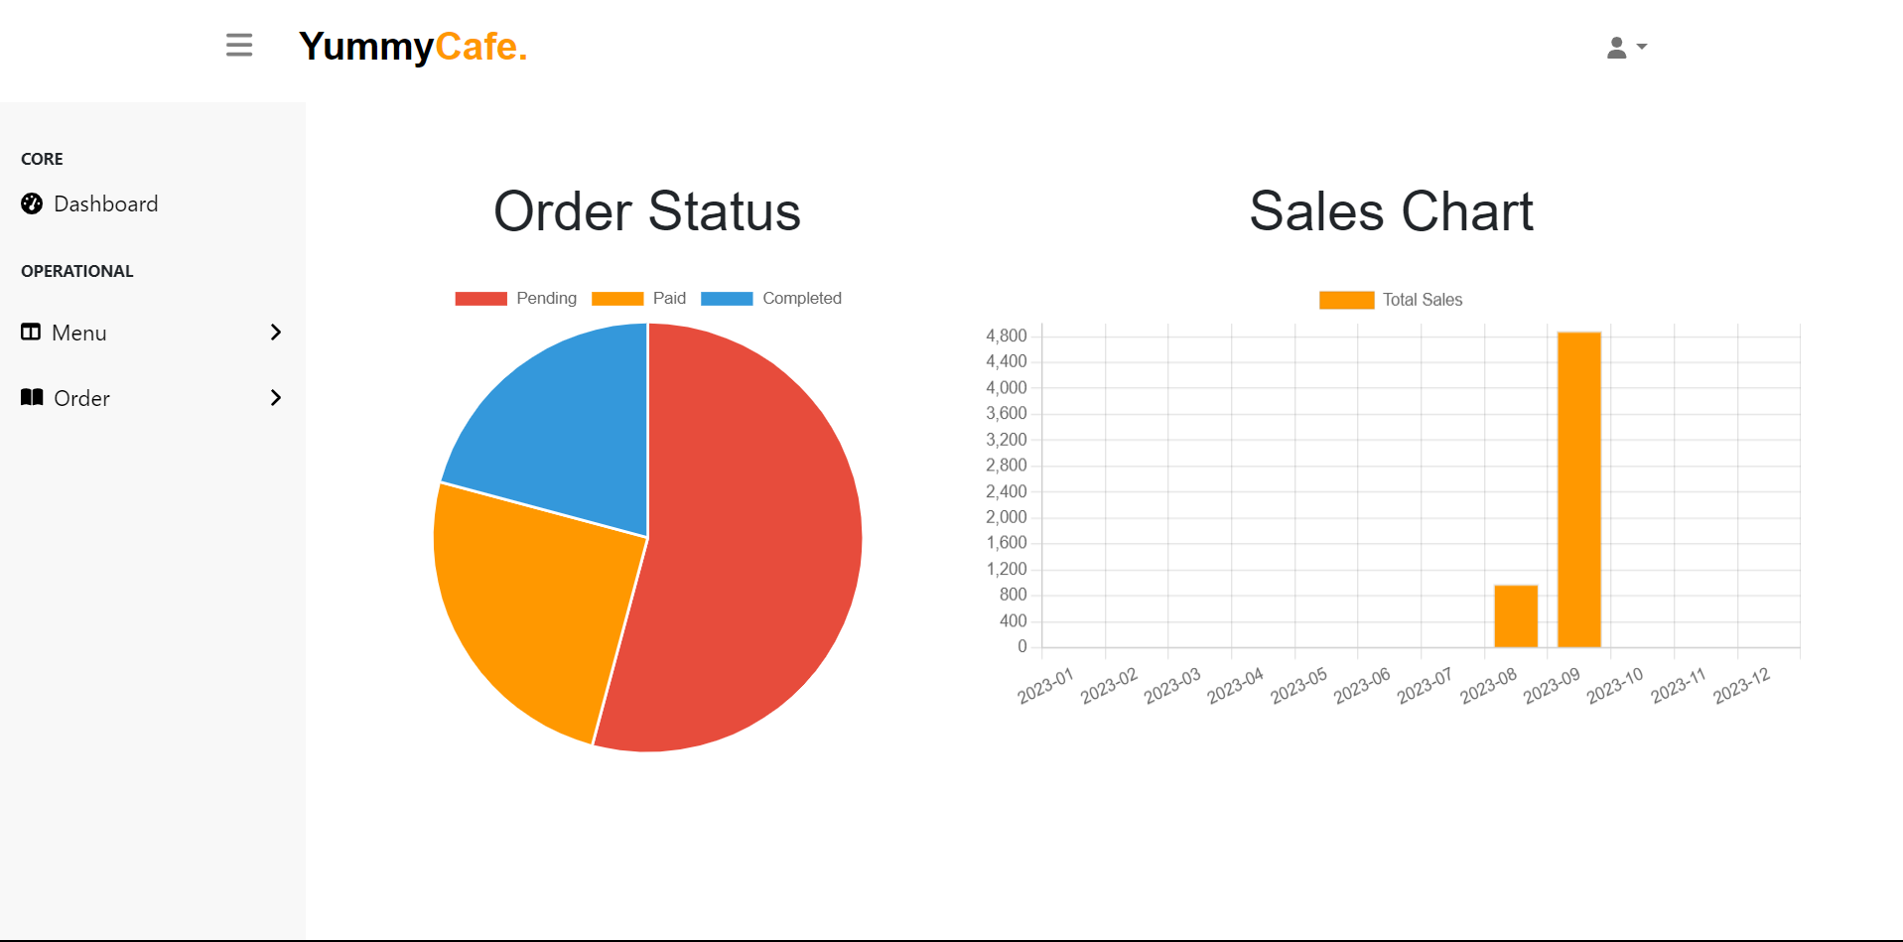

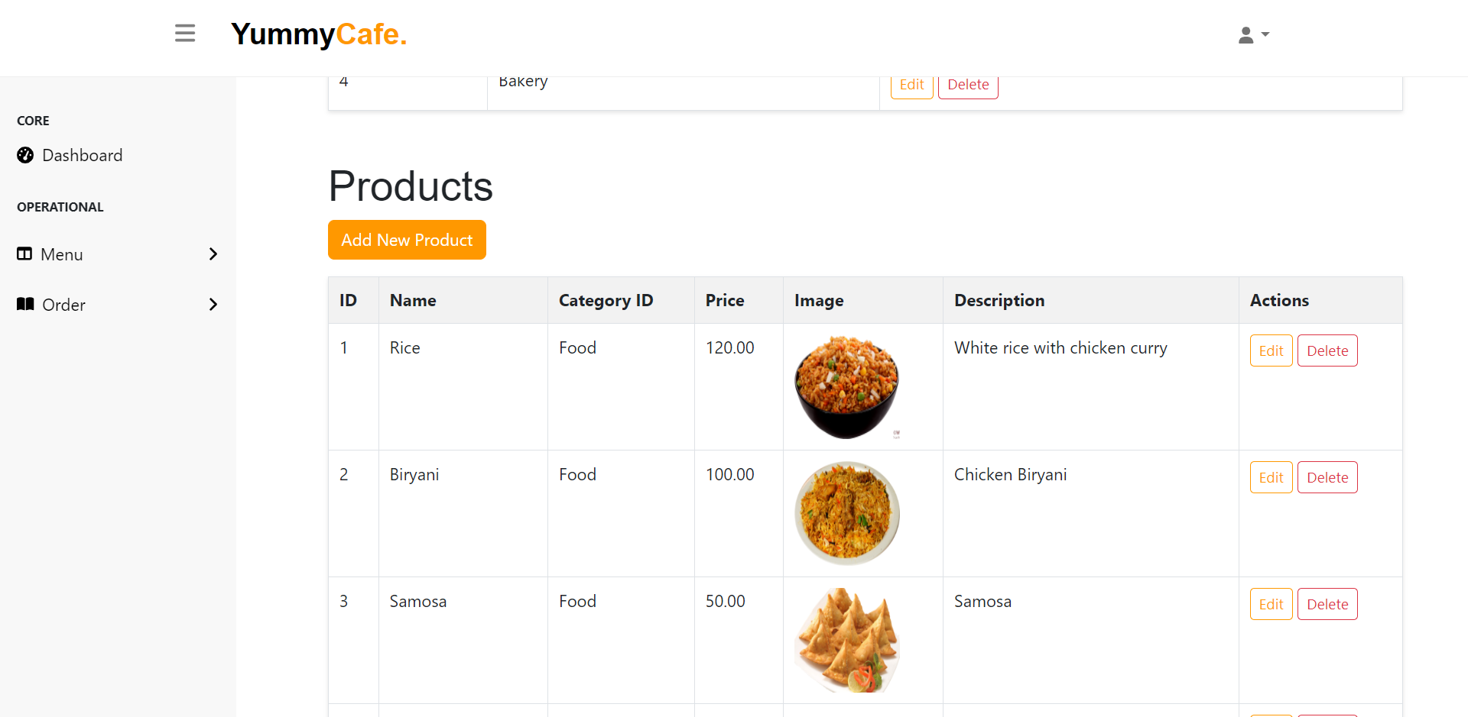

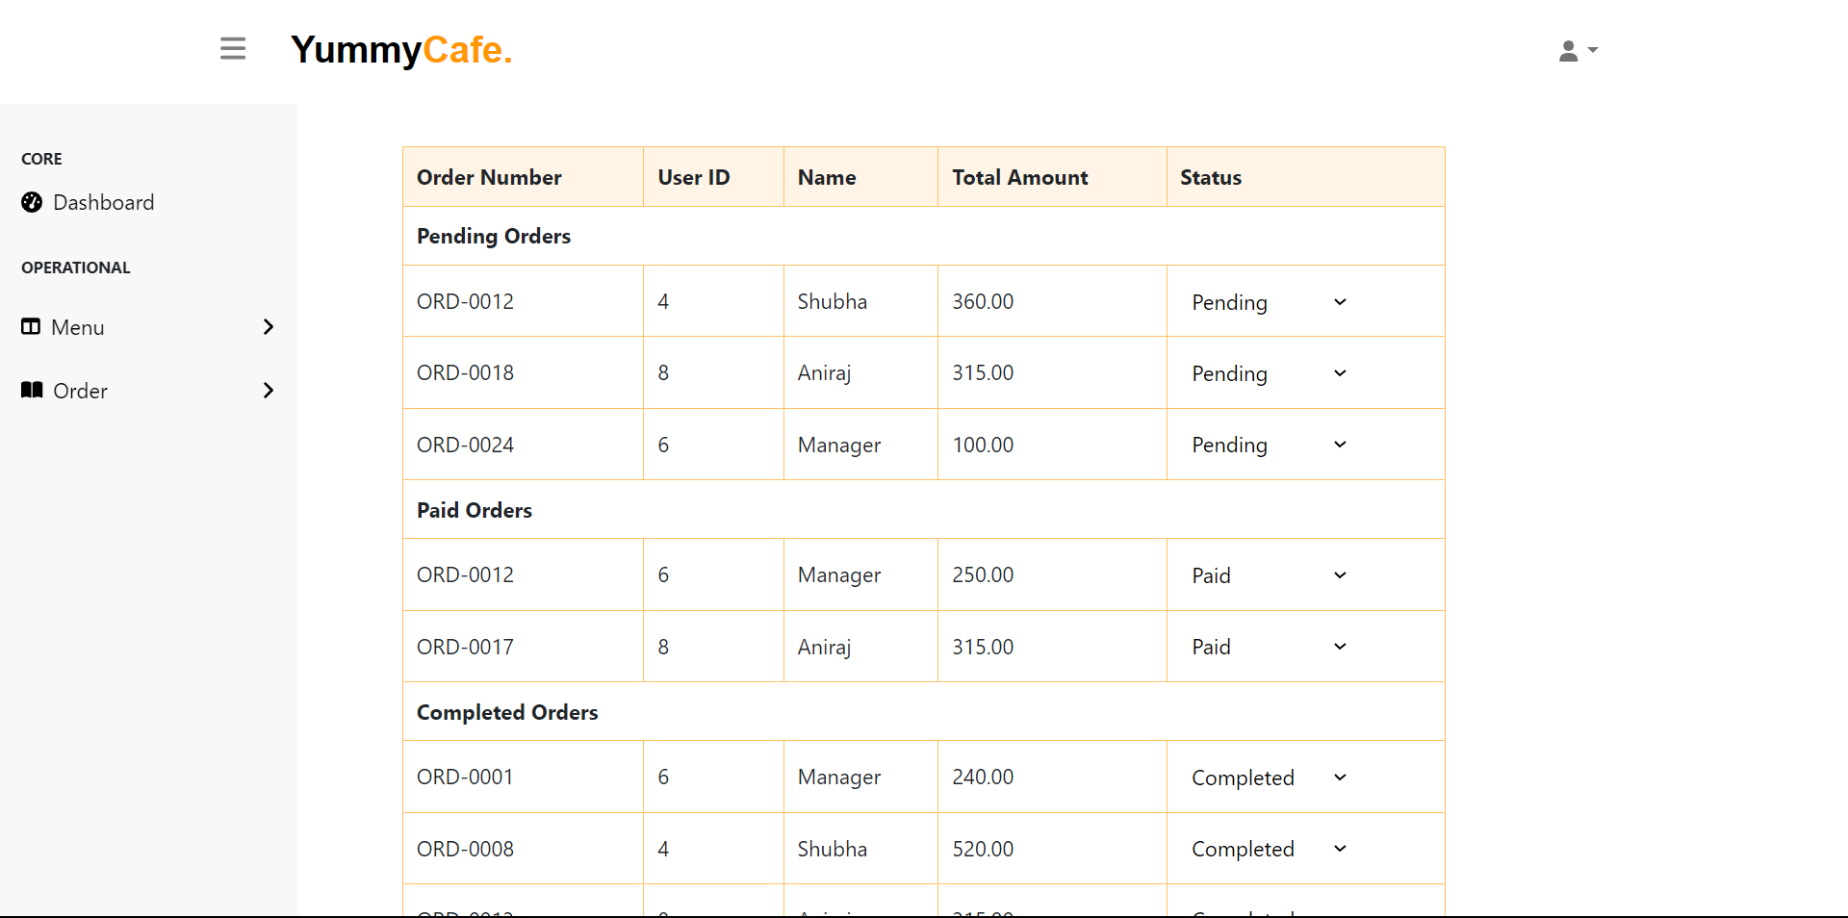

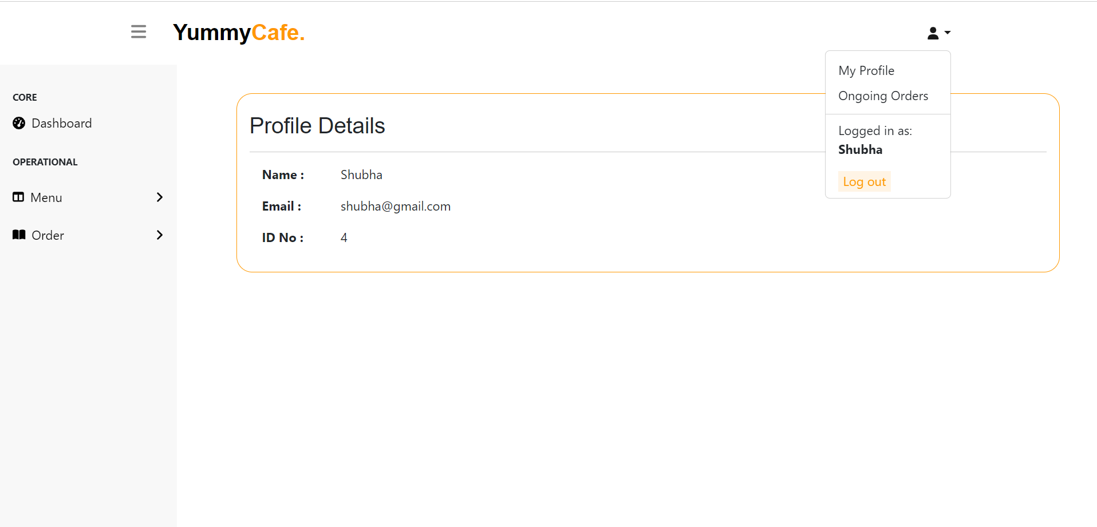

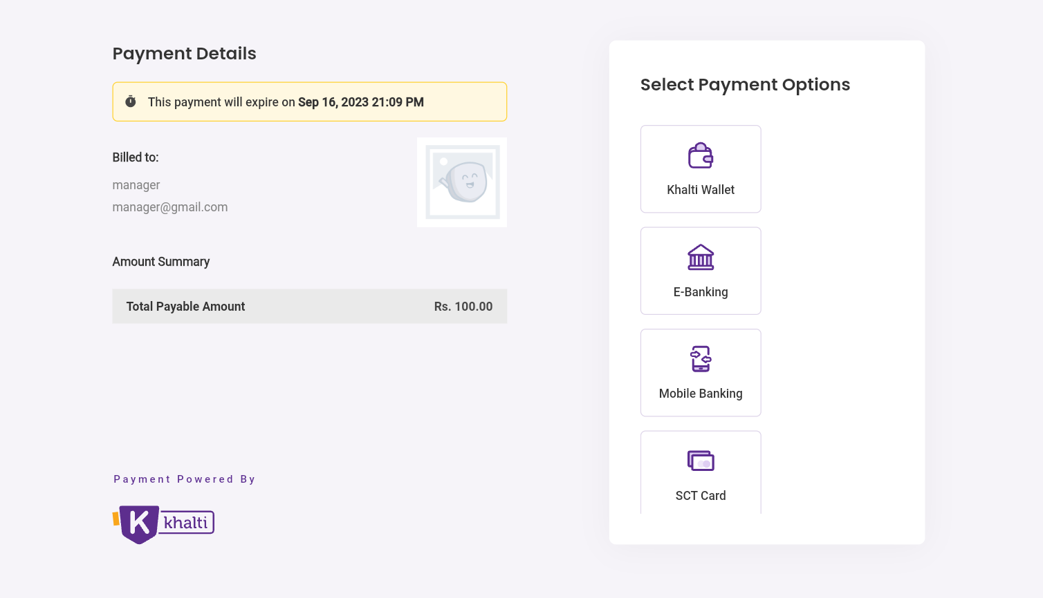

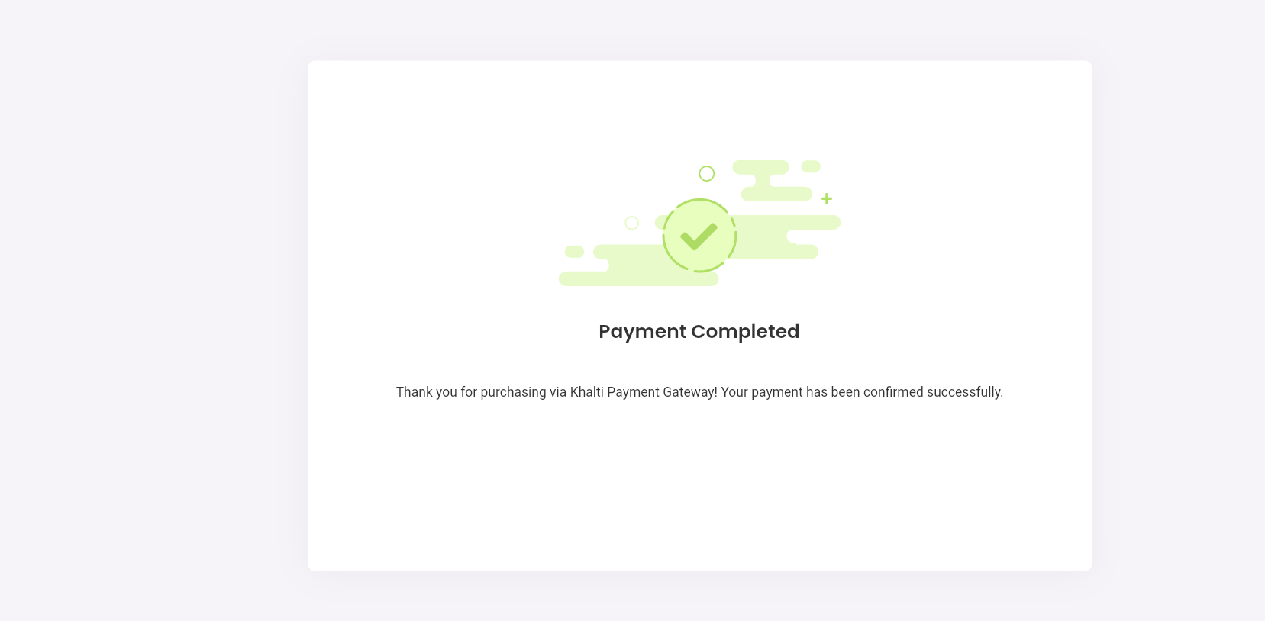

# **APPENDICES II**

